URL: <http://www.leongdental.com.sg/>

At Dr H C Leong Dental Surgeon, we are dedicated to providing our customers with uncompromising quality dental care in a soothing environment. The way we do things reflects our commitment. We believe in delivering value and providing holistic solutions to our customers' oral health needs. Our clinic offers a comprehensive array of oral health care services.

We specially design each treatment room to offer a high ceiling and floor to ceiling windows with a panoramic view of Fort Canning hill, Clarke Quay and the Orchard and River Valley area and the sky above. The high ceiling offers a much greater feeling of space and airiness and many have commented that the view of the sky and clouds gives a relaxing and soothing atmosphere as you are receiving treatment.

**Our commitment to giving you the very best possible oral health care.**

We believe that the quality of care we can provide you is profoundly influenced by 3 elements:

* Technology
* Information (in your hands as well as ours)
* Care, concern and service standards

All these elements are vitally important to providing the most optimal and satisfying outcome to you, our patient.

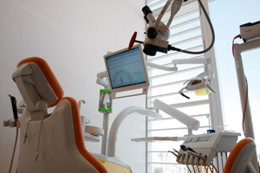 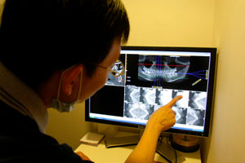

**Examination and consultation**

All examination is carried out under magnification and where required under microscope. The goal is early detection (as almost all oral disease do not cause symptoms at an early stage) which permits early effective intervention resulting in better treatment outcome and cost effectiveness

**Services:**

**Root Canal Therapy**

* Molar
* Premolar
* Front teeth
* Post and Core
* Emergency pain relief

**Oral Hygiene**

* Scaling and Prophylaxis (polishing)
* Jet polishing (Prophyflex) - removal of tough stains
* Root Planing

**Surgical Procedures**

* Dental Extraction
* Surgical Extraction
* Incision and Drainage
* Implant Placement Surgery
* Mini Implant Placement
* Tissue Grafting
* Wisdom Tooth Surgery

**Preventive Therapy**

* Topical Fluoride Application
* Fissure Sealant
* Mouth guards - night use and sports use
* In Office tooth Desensitization

**Aesthetics**

* In Office Tooth Whitening
* Prescription Take Home Whitening

**Restorative Dentistry**

* Tooth Coloured restorations
* Temporary Dressing
* Composite Resin veneers/bonding
* Ceramic Veneers
* Crown
* Fixed Partial Denture (Bridges)

**Orthodontics**

* Fixed Braces
* Retainers

**Removable Dentures**

* Acrylic (plastic)
* Reinforced Acrylic (plastic with wire/wire mesh)
* Chrome Base
* Flexible Base
* Emergency Interim
* Repair

**Diagnostic Imaging**

* Small radiograph
* Cone Beam CT scan

(All our radiographs are digital)

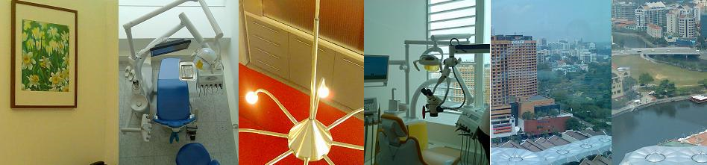

**Doctor credentials:**

**Dr Leong Hon Chiew (BDS Singapore)- Dental Surgeon**

Since qualifing in Dentistry in1996 from National University of Singapore, Dr Leong Hon Chiew began his career  in the School Dental Services for two and a half years, providing dental care services to children in Singapore schools. His early years in private practice began  first as an associate and became an active partner of a major dental group in Singapore from 1999 to 2008. With his years of experience and confidence both as a dental practitioner and clinic management, he embarked a new journey in his career by setting up his own dental practice. His desire is to propel to greater heights the standard of dentistry in Singapore by bringing a unique combination of knowledge, technology and diligence to his work.

Dr Leong is committed to continuing education in all aspects of dentistry. His comprehensive experience are acquired through years of practice and ensuring that each patient is attended to with uncompromised care. The core area of competancy include root canal treatment and wisdom tooth removal. Currently, he has moved on to Implantology and Orthodontics. His belief of continuous improvement has helped achieve a sense of meaningful and fulfillment each day and it brightens up his day to bring satisfaction to his patients.

His fluency in English and Malay are comparable to that of a native speaker. In fact his ability to code-switch has facilitated the flow of communication with his patients from all over the world. Other spoken languages include Mandarin and Cantonese.  Even though Dr Leong demands high standards from himself and his staffs, the comments echoed by his patients are his easy going manner and gentle care.

Dr Leong's professional memberships include:

* Singapore Dental Association
* International Dental Exhibition and Meeting IDEM (2006)
* Singapore Dental Association, Ethic Committee Member and Treasurer, 2006-2007

**Cindy - Dental Assistant:** Cindy brings in Leong Dental over 11 years of experience as a dental assistant. She has assisted Dr Leong for more than seven years. Having opportunity to take care of patients and help them achieve healthy, beautiful smiles makes her job a rewarding experience. Cindy displays genuine care to each one of  the patients and is a great asset to our practice.

**Rochelle - Dental Assistant:** Rochelle is a qualified dentist from Centro Escolar University, one of the leading schools of dentistry in the Phillippines. She joins Leong Dental after almost two years of practicing excellence in private practices in the Phillippines.

**Contact us:** Dr H C Leong Dental Surgeon LLP

Address:

8 Eu Tong Sen Street  
#20-86  
The Central (Office 2)

Singapore 059818

E-mail:

[drhcleong@leongdental.com.sg](mailto:drhcleong@leongdental.com.sg) This e-mail address is being protected from spam bots, you need JavaScript enabled to view it.

Mobile Phone:

96711096